HK INSTITUTE OF VOCATIONAL EDUCATION
DEPARTMENT OF INFORMATION AND COMMUNICATIONS TECHNOLOGY

ITP4910 Software Development Project

LAB 03 – C# Basic Controls II with Control Statements

Objectives:
- To learn the basic controls Combo box and Message box in C#
- To learn the basic control statements in C#

Part A: Combo Box

The following exercise demonstrates the function of a ComboBox control, together with the use of a message box.

Combo boxes have very similar properties as list boxes, except that we can only choose one item from a combo box, while we can choose as many items as we like in a list.

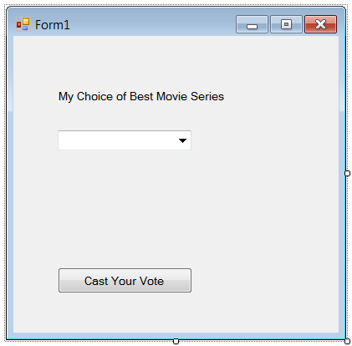

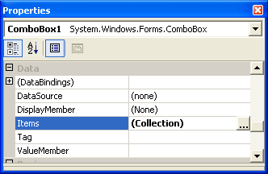

If we set the DropDownStyle property of Combo Box to DropDownList, the combo box will not allow users to key in their own “best movie series”.

Last time, we use items.add to insert the new items in a list box while the form is loaded. Another method to add the items into their place is to use the Items property in the properties window. You will give a multi-line text box to enter the lines that will appear in your combo box.

Your program should allow the user to choose his/her best movie series from the combo box and show the following message by a message box when the voting button is clicked:

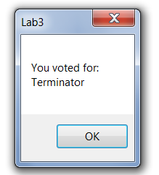

- Create a new project of type Windows Applications. Enter Lab03 as its name.
- Insert one label, one combo box and one button into the form as follows:

Properties Table

Object | Property | Setting
Button | Name  Text | btnCast  Cast your vote
Label | Name  Text | lblCast  My Choice of Best Movie Series
ComboBox | Name  DropDownStyle | cboMovie  DropDown

- Click the button in the Items property of cboMovie and enter the names of some movie series in the String Collection Editor.

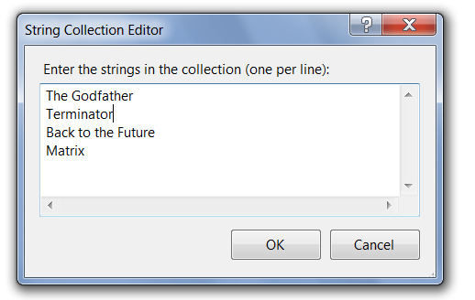

- Add code for the event btnCast_Click.
Hints:
- To call out a message box, you can call the function MessageBox.Show(msg) where msg is the message that will be shown in the message box.
Eample: MessageBox.Show(“You are welcomed”);
- To start a new line in the text in a VB control, we can use the build-in constant “\n”.
Example: MsgBox(“My name is\nBill Gate”);

- Run and test the program.
- Change the DropDownStyle property of Combo Box and test the program to see the change.

Part B: Easy Control Statements

Looping Exercise 1

You are requested to develop a project to illustrate the growth of money in a savings account. When the user presses the button, values for Amount and Interest Rate are obtained from text boxes and used to calculate the money value after 10 years and the number of years until the money reaches $1,000,000.

Use the form design below.

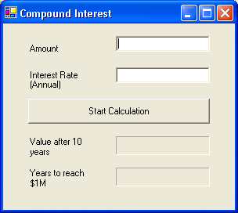

Object Property Setting
Form1 Text Compound Interest
lblAmount Text Amount
txtAmount Text (blank)
TextAlign Right
lblRate Text Interest Rate (Annual)
txtRate Text (blank)
TextAlign Right
btnCalculate Text Start Calculation
lblValue Text Value after 10 years
lblValue2 AutoSize False
BorderStyle Fixed3D
Text (blank)
TextAlign Middle Right
lblMillion Text Years to reach $1M
lblMillion2 AutoSize False
BorderStyle Fixed3D
Text (blank)
TextAlign Middle Right

Hints:
The balance at the end of each year is (1+r) * balance, where r is the interest rate.
The balance at the end of 10th year = balance * (1+r)¹⁰

Looping Exercise 2 (Using For)

Create a form according to the layout as follows:
- Add 2 Listboxes to hold items in Shop and Cart.
- Add the items Apple, Banana, Grape, and etc in the Shop listbox.
- Add a textbox and a button to enable the user to add an item to the shop.
- Add 2 new buttons (the two arrows) which allow the user to move items from one listbox to another. First select an item in one listbox and click the arrow button to move the item. You need to write the code for the two boxes (Hints: Use the selectedItem property together with the add and remove methods in Items)
- Add a button to enable the user to count the number of items in the shop and cart.
- Add a button to enable the user to clear the content of the cart. When you clear the content of the cart, you need to return the fruits to the shop. (Hints: Use a for loop and Items(n) method in Items in the listbox to remove and replace the fruits in the cart)
for (i=0; i<lstCart.items.count; i++) {
...
}
- Add the necessary error checking procedure to warn the user when no item has been selected if times allowed. (Hints: use the Count() method in Items in the listbox)

